**A**

**SYNOPSIS**

**ON**

**Forms World**

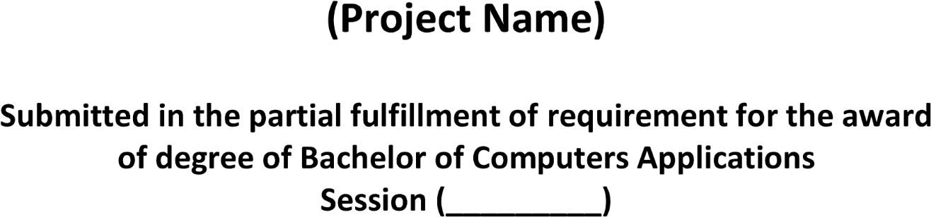

**2020 - 2023**

**Submitted by:-**

***Shubham Dahiya***

***20012041042***

**Under supervision of:-**

***Ms. Parull Bhardwaj***

***Assist. Professor***

